
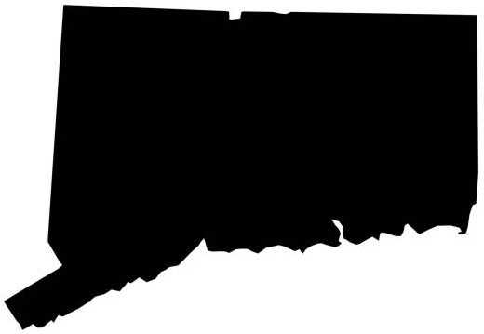
Connecticut RID
Membership Application / Renewal
July 1st, 2026 to June 30th, 2027

Please send this form completed to “CRID”
Scan + email or mail to: Paul Atkinson
CRID.Treasurer1971@gmail.com P.O. Box 348
Norfolk, CT. 06058

*Indicates Required Information TODAY’S DATE:____________
*Name: |  |  |  |  | ❑ New ❑ Renewal
*Address:
*City: |  | *State: | *Zip: |  |  | *RID #
*Phone: V / TTY / VP |  | *Email:
Confidential Information:  This information will not be listed online or released to anyone.  ❑ Address ❑ Phone ❑ Email | I am a member of national RID: ❑ Yes ❑ No  I am currently RID certified: ❑ Yes ❑ No  Current Certification(s): _______________ |  |  | I am a member of national NAD: ❑ Yes ❑ No  I am currently NAD certified: ❑ Yes ❑ No  Current Certification(s): ____________
*MEMBERSHIP CATEGORIES*
Membership category criteria are listed on the next page
❑ Certified ❑ $35.00 (1 Year)  ❑ $60.00 (2 Years) |  | ❑ Student/Senior ❑ $25.00 (1 Year)  ❑ $35.00 (2 Years)
❑ Associate ❑ $35.00 (1 Year)  ❑ $60.00 (2 Years) |  | ❑ Organizational ❑ $25.00 (1 Year)  ❑ $35.00 (2 Years)
❑ Supporting ❑ $25.00 (1 Year)  ❑ $35.00 (2 Years) |  | Contribution ❑ $10.00 ❑ $20.00  (optional) ❑ $15.00 ❑ Other $________
CONTRIBUTIONS ARE ALWAYS WELCOMED!  For gifts of $15 or more,  contributors will receive recognition.  All contributions are tax deductible  to the extent allowed by law.  We are grateful for your generosity,  Thank You so much! |  | 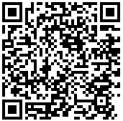  SCAN HERE  for electronic payment  *Membership Dues: $__________  Contribution: (optional) $__________  *TOTAL Amount Enclosed: $__________  Check or Money Order # ___________________
Connecticut Registry of Interpreters for the Deaf
Membership Application / Renewal Form

MEMBERSHIP CATEGORIES
VOTING |  | NON-VOTING
Certified | For any Interpreter or Transliterator currently holding a valid certification from RID/NAD who may regularly attend meetings and exercise their right to vote.  Additional Benefit  2-Year Memberships are eligible for 25% rebates on professional development fees | Supporting  or  Student | For any certified or non-certified individual with an interest in supporting the purposes and activities of the organization who is unable to regularly attend meetings and unable to vote on business before the organization.
Associate | For any individual who is actively engaged in or working to interpret ASL-English and/or the transliteration of English but does not hold current certification from RID/NAD and may regularly attend meetings and exercise their right to vote.  Additional Benefit  2-Year Memberships are eligible for 25% rebates on professional development fees | Organizational | For any organization or institution with an interest in supporting the purposes and activities of CRID.

CONNECTICUT RID - OUR MISSION
The Connecticut Registry of Interpreters for the Deaf (CRID) was established in 1971, and is one of more than 60 local chapters affiliated with the national Registry of Interpreters for the Deaf (RID).

When you become a member of CRID you are supporting our goals to:
- Promote and maintain the NAD-RID Code of Professional Conduct (CPC) for Interpreters and Transliterators of ASL-English.
- Foster professional support for Interpreters (novice through experienced) by attaining new information, knowledge, & current practices in fields related to the interpreting profession.
- Provide the opportunity for an exchange of ideas and information through workshops, trainings, events, meetings and social gatherings.
- Encourage Interpreters and professionals in related fields, and community members to participate in the advancement of the Interpreting field & American Deaf Communities.
- Support organizations and activities of the Deaf and Hard of Hearing communities.

CRID members are comprised of Interpreters, Deaf consumers, Allies, Professionals, and Community Supporters. Discounted prices for CRID sponsored workshops are available to all members. CRID Members are encouraged to attend and participate in public membership meetings, workshops, social events, and other CRID sponsored activities. Thank you for your commitment.

Please allow 4-6 weeks for processing time. An email will be sent acknowledging receipt of your payment & form. To vote at CRID general membership meetings you must be a voting member of CRID and a member in good standing of RID, Inc.
OFFICE USE ONLY:

Date Received: _________________ Date Receipt Letter Sent: __________ Membership term: July 1, __________ through June 30, __________

